Need to incorporate these gently into the main quiz. Some of these are more fundamental than others, so they should be incorporated first. Continue generating problems from the book to add to this set and then fold them into the main quiz on a weekly basis.
- (6-1ex3) Write the equation for the line that passes through (-1, 4) and (3, -2).
- (6-5) What would be the slope of a line perpendicular to 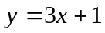?
- (6-5ex1) What would be the slope of a line parallel to 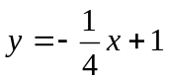?
- (5-5) What is the formula for a direct variation?
- (6-3) Give the standard form of a line.
- (6-3ex1) Find the x and y intercepts of 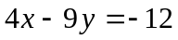
- (6-3ex3) Identify whether the following lines are horizontal or vertical: 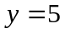, 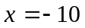, 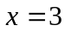, 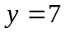
- (6-3ex3) Identify whether the following lines are horizontal or vertical: , , ,
- (6-3ex4) Write 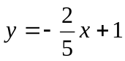 in standard form using integers.
- (6-4) Give the point-slope form of a line, and describe each variable.
- Chapter 7, see the “Solving Linear Systems” worksheet.

